**[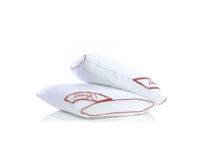](javascript:PopupImage('../jpg/010/4/010444_1.jpg'))**